

**CSE488: Big Data Analytics**

**[SPRING 2023]**

**Assignment**

**Online Assignment Lab-4**

**Submitted by:**

Student ID: 2019-2-60-072

Student Name: Mujahidul Islam

Code:

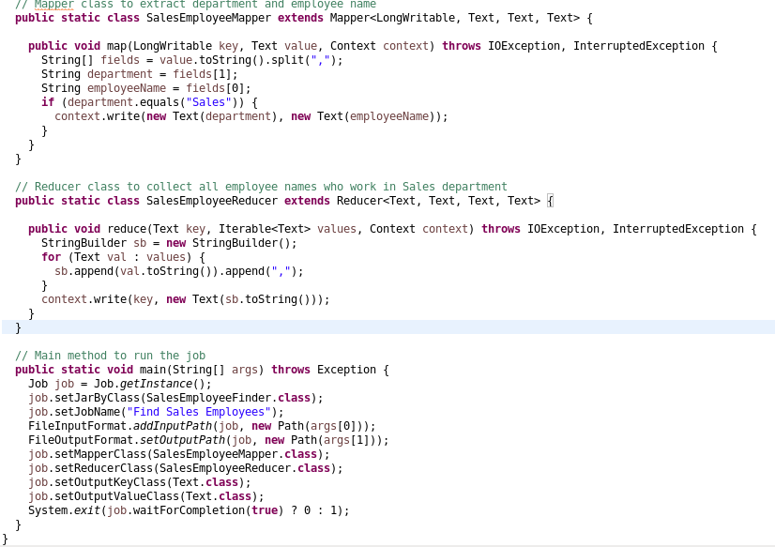

Input Files

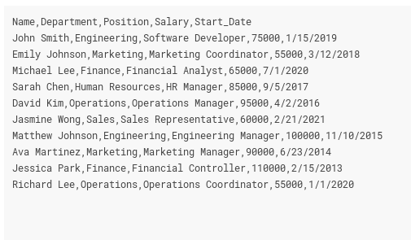

Execution Command Prompt:

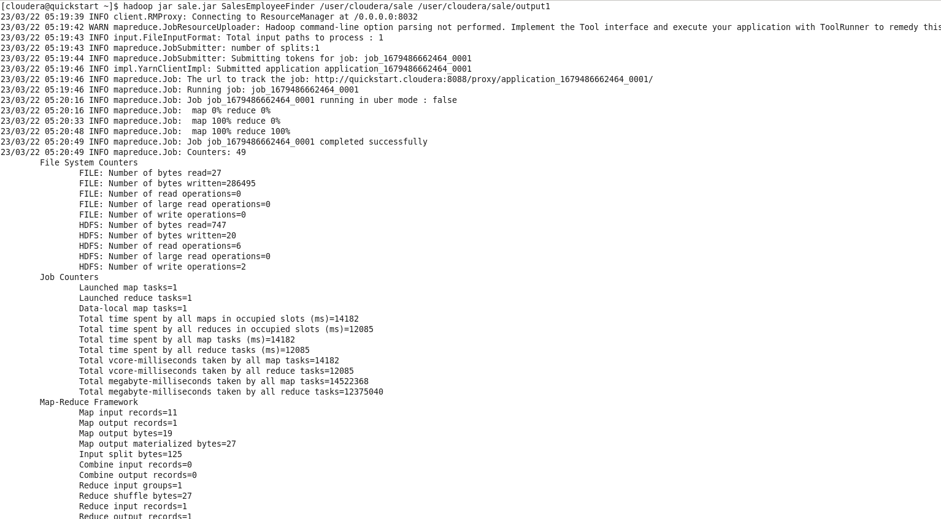

Output:

